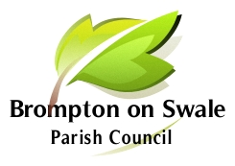

Brompton on Swale Parish Council
Parish Clerk: Martin Reynolds, 31 St Pauls Drive, Brompton on Swale, Richmond DL10 7HQ

Tel: 07849 048581 email: bosparishclerk@hotmail.com

Parish Council meetings take place at the Community Sports Hall,
Honey Pot Road, Brompton-on-Swale, DL10 7HT.

Meeting Dates for 2023

12 January 7.00pm

2 March 7.00 pm

13 April 7.00 pm

18 May – Annual Parish Meeting and AGM 7.00 pm

6 July 2021 7.00 pm

7 September 7.00 pm

26 October 7.00 pm

7 December 7.00pm

